Name: Roll no: Section:

**SIR SYED UNIVERSITY OF ENGINEERING & TECHNOLOGY**

**COMPUTER SCIENCE & INFORMATION TECHNOLOGY DEPARTMENT**

**Fall 2023**

**Applied Physics (MS-111T)**

**QUIZ 1B**

Semester: I Batch: 2023F

Max Marks: 02

Instructions:

* Attempt all questions

Question 01

Fig: 1 shows a hypothetical closed cylinder of radius R immersed in a uniform electric field E, the cylinder axis being parallel to the field. What is ǾE for this closed surface?

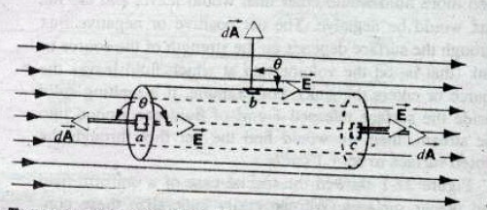

Fig: 01